Name: V Vyas
SRN: PES2UG24CS569
Section: 5J
Lab 6: Code Coverage
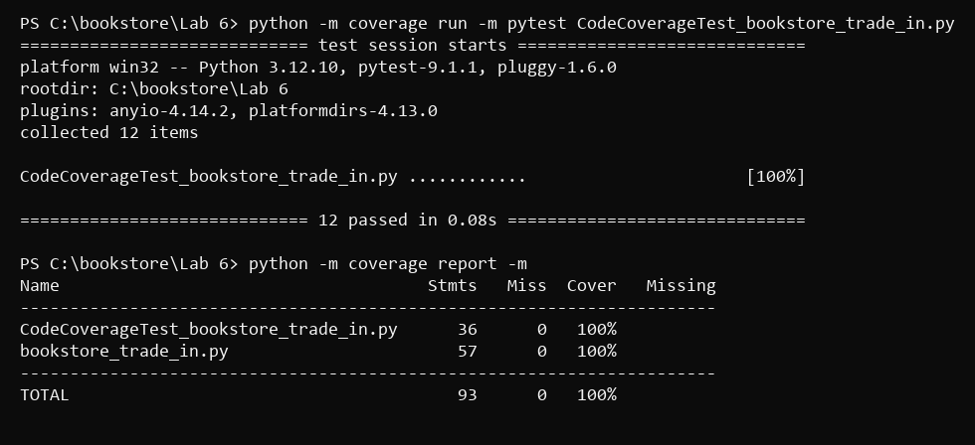
Lab 6: Branch Coverage


